Cross Site Scripting on portswigger

I’m gland to inform you that I solves 5 lab of vulnerable website from Portswigger
Website: https://portswigger.com
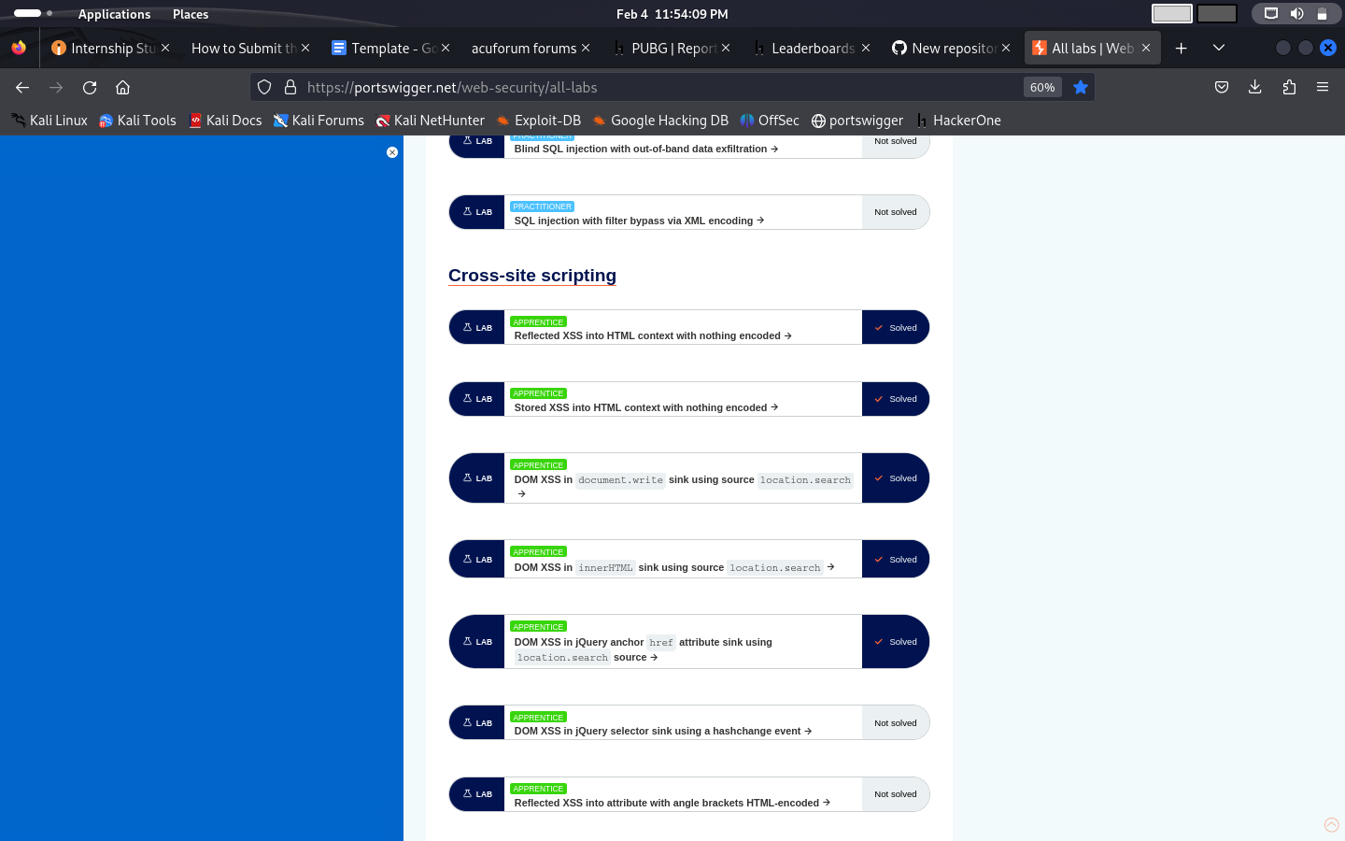

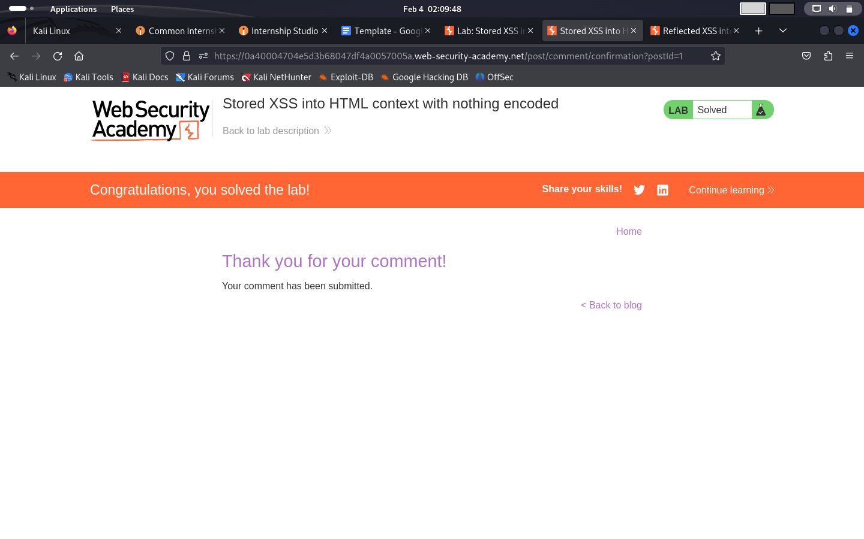
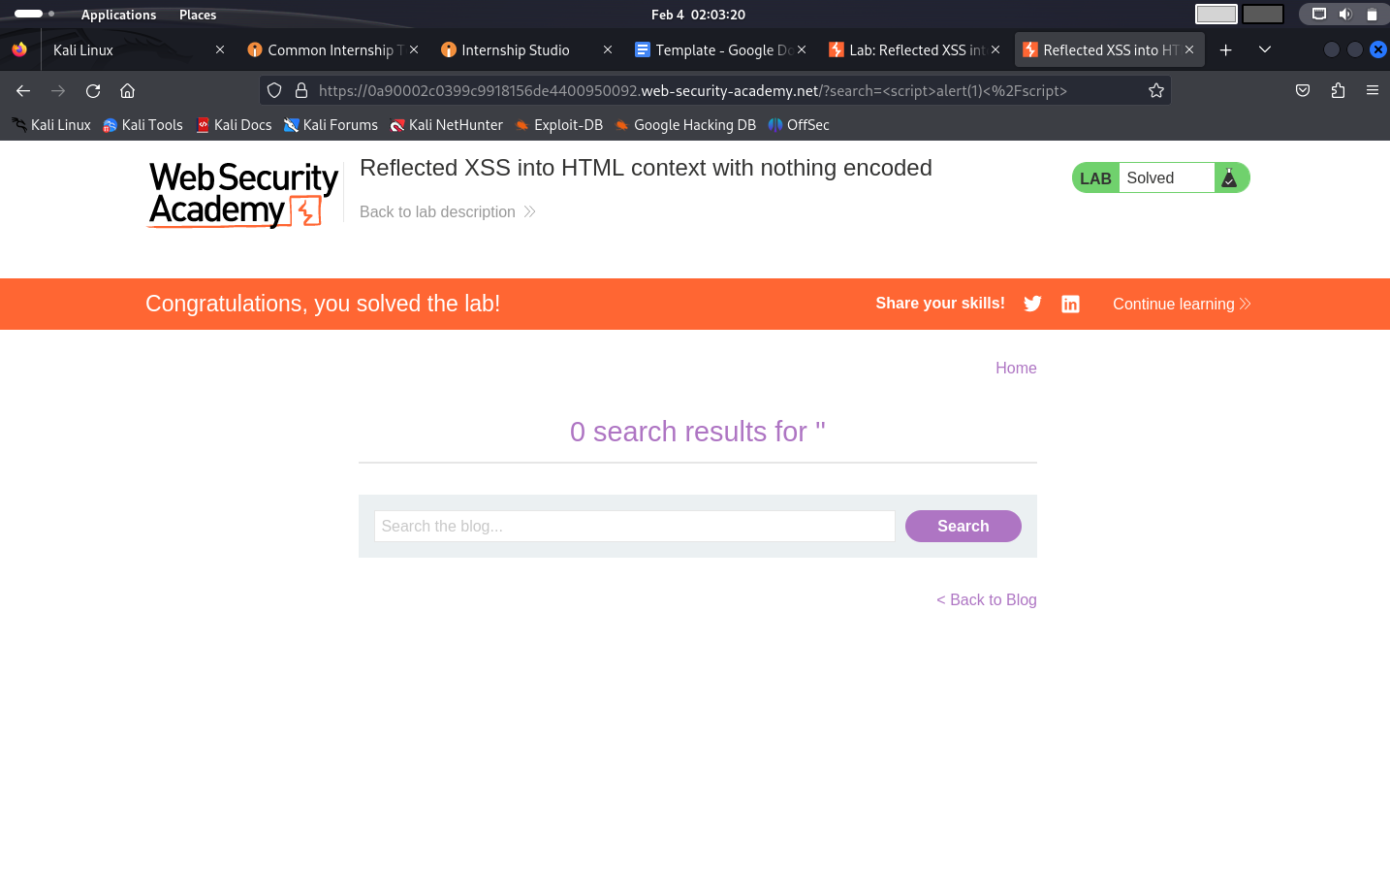
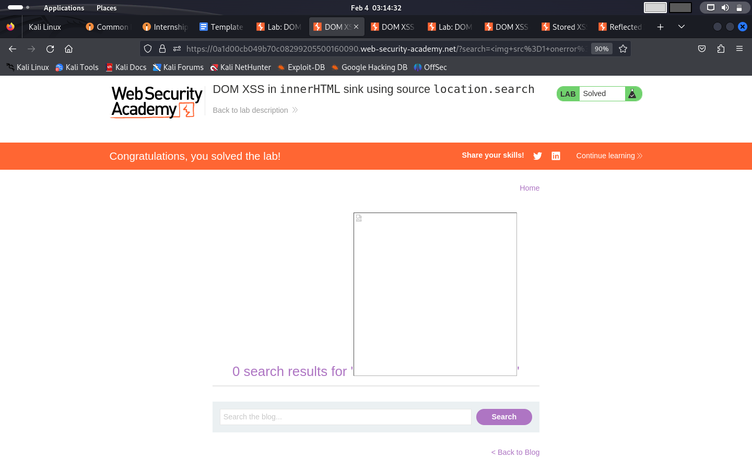
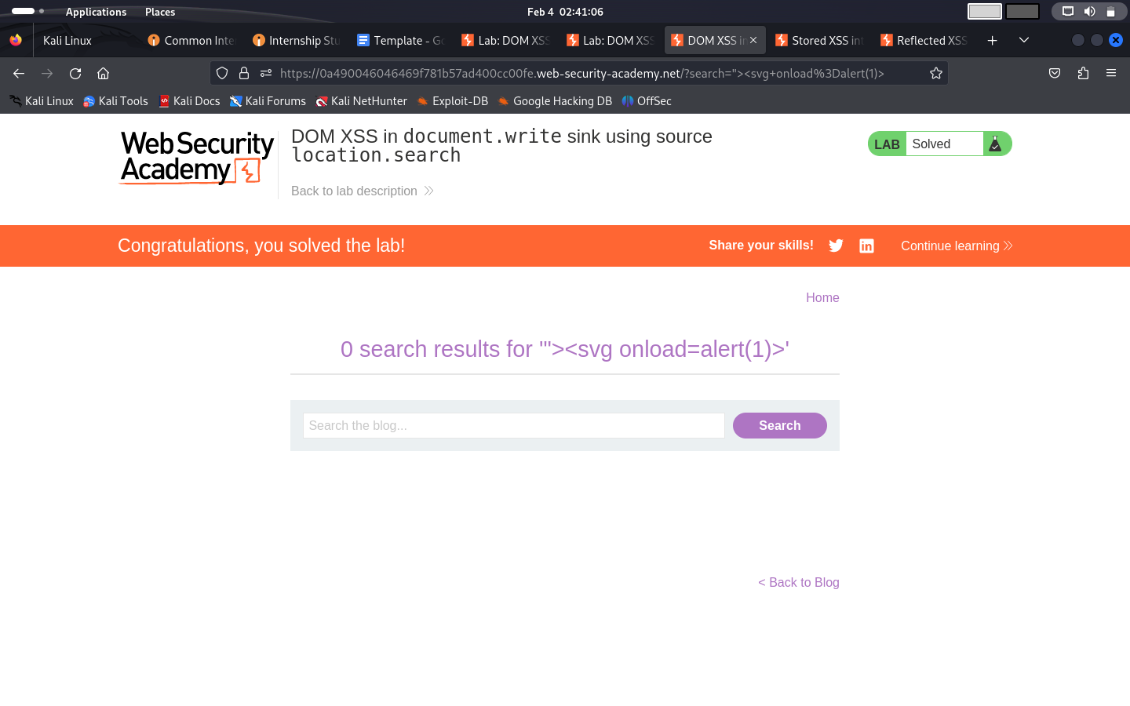
Website with vulnerability

Title:Cross Site Scripting

Domain: Vulnweb.com
Sub Domain:testasp.vulnweb.com

Hey , the website http://testasp.vulnweb.com has vulnerable to an injection vulnerability .
Attacker are use to script on search box and use for unauthorize work.

Proper steps to reproduce:-
Step 1: visit the website http://testasp.vulnweb.com
Step 2: on the top of the screen find the search box
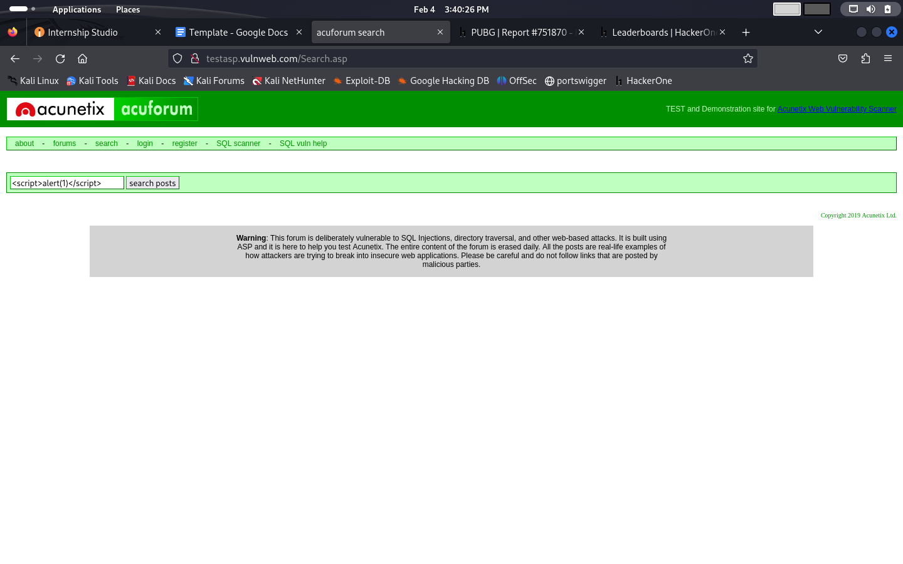

Step 3: Injectthis script in search box $<script>alert(1)</script>

Step 4: press enter

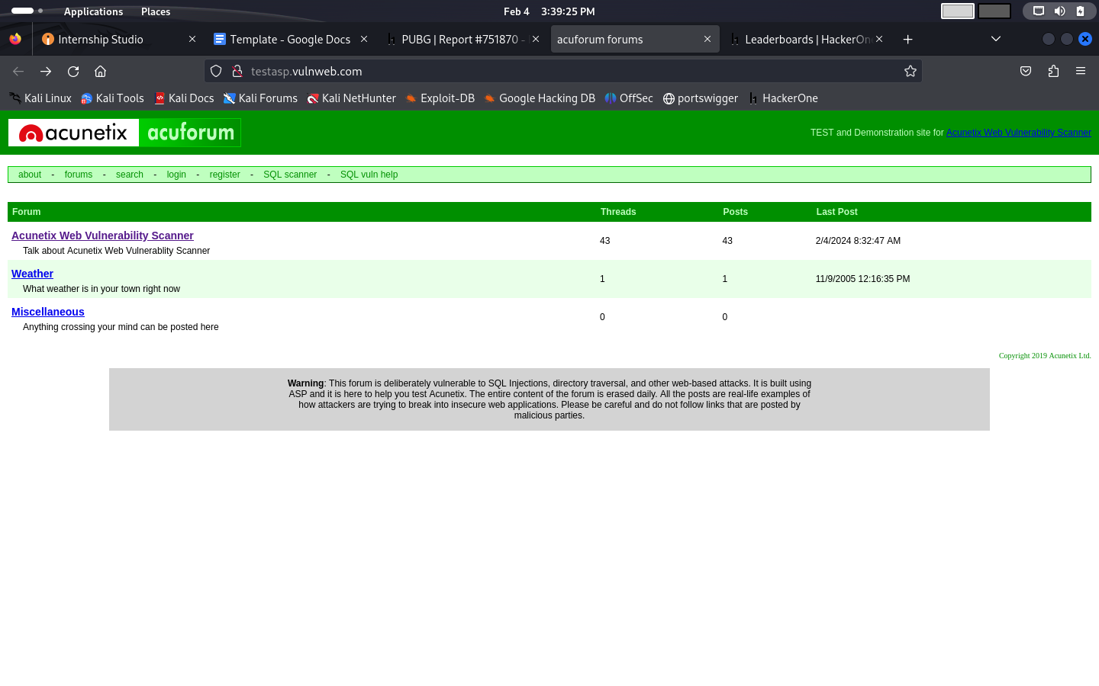

Mitigation: If you want to prevent the website vulnareble of CSS the you can just enable noscript on browser,validation,encoding and strictly rpohibit HTML code in inputs.

Here is the video how can we can reproduce the vulnerability:-

